A Mini Project Report on

**ICreate**

Submitted in partial fulfillment of the requirements for the award of the degree of

#### Bachelor of Engineering

in

#### Computer Engineering

by

#### Amit nara (20102067)

#### Smit panchal (20102027)

#### Bhavesh pawar (20102069)

#### Ujjwal pal (20102054)

Under the Guidance of

**Prof.Ramya R.B.**



##### Department of Branch Name

A.P. Shah Institute of Technology G.B.Road,Kasarvadavli, Thane(W), Mumbai-400615

UNIVERSITY OF MUMBAI

##### Academic Year 2021-2022

**Approval Sheet**

This Mini Project Report entitled ***“*ICreate”** Submitted by **Amit nara (20102067),** **Smit panchal (20102027),Bhavesh pawar (20102069),** **Ujjwal pal (20102054)**is approved for the partial fulfillment of the requirement for the award of the degree of ***Bachelor of Engineering*** in ***Computer Engineering*** from ***University of Mumbai***.

Prof.Ramya R.B**.**

Guide

Prof. Sachin H Malave

Head Department of Computer Engineering

Place:A.P.Shah Institute of Technology, Thane Date:December 16, 2021

#### CERTIFICATE

This is to certify that the mini project entitled ***“*ICreate*”*** submitted by **Amit nara (20102067),** **Smit panchal (20102027),Bhavesh pawar (20102069),** **Ujjwal pal (20102054)**for the partial fulfillment of the requirement for award of a degree ***Bachelor of Engineering*** in ***Computer Engineering .***to the University of Mumbai,is a bonafide work carried out during academic year 2021-2022.

Prof.Ramya R.B.

Guide

Prof. Sachin H Malave Dr. Uttam D.Kolekar Head Department of Computer Engineering Principal

External Examiner(s) 1.

2.

Place:A.P.Shah Institute of Technology, Thane Date:December 16, 2021

#### Declaration

We declare that this written submission represents our ideas in our own words and where others’ ideas or words have been included, We have adequately cited and referenced the original sources. We also declare that We have adhered to all principles of academic honesty and integrity and have not misrepresented or fabricated or falsified any idea/data/fact/source in our submission. We understand that any violation of the above will be cause for disciplinary action by the Institute and can also evoke penal action from the sources which have thus not been properly cited or from whom proper permission has not been taken when needed.

———————————————

(Signature)

———————————————

**Smit panchal (20102027 )**

**Amit nara (20102067 )**

**Bhavesh pawar ( 20102069 )**

**Ujjwal pal ( 20102054 )**

Date:December 16, 2021

**Abstract**

Nowadays in this modern world privacy has become a very important and necessary topic for the users of various applications and websites. The user’s concern towards his/her own online privacy is growing day by day.

Thus we need a tool to protect the privacy of the users by encrypting the data that the user’s don’t want to show to anyone accidentally. This is where our website Secerative comes in use. Our website provides options to encrypt text as well as file that the user want to keep secret.

Our website provides user options to either paste text in a textbox that they want to encrypt or upload the file that they want to encrypt , and then with a simple click they get the encrypted text or file thus helping to protect data of the user.

# **Contents**

1. Introduction 1
   1. Problem Definition 1
   2. Objectives 2
   3. Scope 2
2. Existing System/Project 3
3. Technology Stack 4
4. Benefits and Applications 5
   1. Benefits for society 5
   2. Benefits for environment 5
   3. Applications. 5
5. Project Design 6
   1. Proposed System 6
   2. Flow of Modules. 7
   3. Data Flow Diagram. 8
   4. Modules of the System…………………………………………………………………………………………9  
      5.4.1 Registration module
      1. Feedback form
6. Project Implementation
7. Result
8. Bibliography
9. Appendices

1. **Introduction**
   1. **Problem Definition –**

1. The project ICreate objective is to create an ID card for students and employees as instructed.
2. They can Design one side or both, add background images, include custom and system data using an idcard generator ID cards can be generated in bulk or individually for each user.
3. The primary goals and purposes are to reduce human effort and develop the automated id card.

* 1. **Objectives –**

Encryption plays an important role in securing many different types of information technology (IT) assets. It provides the following:

**1. Confidentiality** - Confidentiality encodes the message's content.

**2. Authentication** - Authentication verifies the origin of a message.

**3. Integrity** - Integrity proves the contents of a message have not been changed since it was sent.

* 1. **Scope –**

1. ID cards have become a crucial part of the business world, making it possible to simultaneously simplify employee and visitor identification and enhance a company’s integrity and security.
2. ID cards typically include an employee’s name, photo, job title and department, making quick personal identification a snap. As technology advances, however, ID cards are now being used in a variety of ways to help businesses protect themselves, build relationships and streamline their operations.
3. ICreate will assure the security of your work and personal details. It will be accessible from anywhere and will be available handy to everyone.

1. **Existing System / Project**

There are some existing ID Card makers which are both free as well as paid.

Some existing systems are –

**Paid –**

* AxCrypt
* Microsoft OneDrive

**Free –**

* VeraCrypt
* Folder Lock

1. **Technology Stack**
2. **Frontend** – HTML , CSS and Javascript
   1. Front-end web development, also known as client-side development is the practice of producing HTML, CSS and JavaScript for a website or Web Application so that a user can see and interact with them directly.
3. **Backend** – Python , php
   1. Python has a simple syntax similar to the English language. Python has syntax that allows developers to write programs with fewer lines than some other programming languages. Python runs on an interpreter system, meaning that code can be executed as soon as it is written. This means that prototyping can be very quick.
   2. PHP (Hypertext Preprocessor) is known as a general-purpose scripting language that can be used to develop dynamic and interactive websites. It was among the first server-side languages that could be embedded into HTML, making it easier to add functionality to web pages without needing to call external files for data.
4. **Database** – SQL
   1. SQL is used to communicate with a database. According to ANSI (American National Standards Institute), it is the standard language for relational database management systems. SQL statements are used to perform tasks such as update data on a database, or retrieve data from a database.
5. **Benefits and Applications**
   1. **Benefits for society**

* Encryption is Cheap to Implement
* Encryption Can Save You from Regulatory Fines
* Encryption Can Help to Protect Remote Workers
* Encryption Increases the Integrity of Our Data
* Encryption Can Increase Consumer Trust
  1. **Application**

1. You Can Use It Across a Variety of Devices
2. It Helps You Stay Safer When Working Remotely
3. Encryption Is a Privacy Safeguard
4. Encryption Could Provide a Competitive Advantage

1. **Project Design** 
   1. **Proposed System**

* Our Encryption Website will have majorly 2 parts :

1.Text encryption

2.File encryption

* Inside the text encryption section the user will be provided with a textbox where the user can enter the text that they want to be encrypted and after clicking the encrypt button below it the user will receive an encrypted text in a textbox at the end of the page.
* Inside the File Encryption section the user will have a option to select a file from their computer and upload it , after uploading the file and clicking on the encrypt button below it the user will get the password protected file which can be downloaded.
* The user-Interface is very easy to understand and minimal in design.
  1. **Flow Of Modules**

1. **Registration module**

**2. Text Encryption**

**3. File Encryption**

**4. Feedback form**

* 1. **Data Flow Diagram**

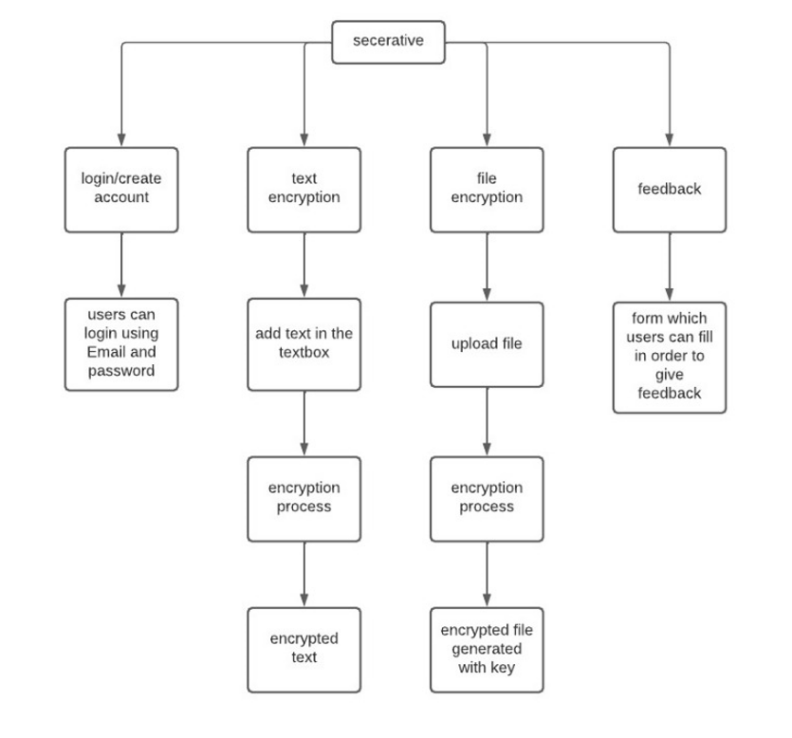

* 1. **Modules Of The System** 
     1. **Registration Module-**

Registration module was successfully implemented. It requires user to give a valid email address and full name in order to sign up/ login.

* + 1. **Id Card Generation –**

The project contain different designs for the ID card. These templates designs are for the user to choose and make one for themself.

* + 1. **Certificate Generation –**

The certificates module has different templates. The certificate module will

also contain all the certificates which you have created in the project's section inside the module.

* + 1. **Feedback Form –**

Feedback form module was successfully implemented. It has three sections, one of which allows the user to give feedback about the service, which gets directly mailed to the admin**.**

1. **Project Implementation**
2. **Links**

This is the code for all the links to get us the desired styling for the website.

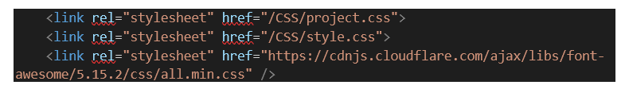

1. **Navigation menu**

This code consists of buttons for Sign Up, Login, Features, Home, Create, Contact Us. These buttons take to the pages which will do the work which is assigned to them. Tag <a></a> it is known as anchor tag which holds the link with help of (href). The element also represents a hyperlink.

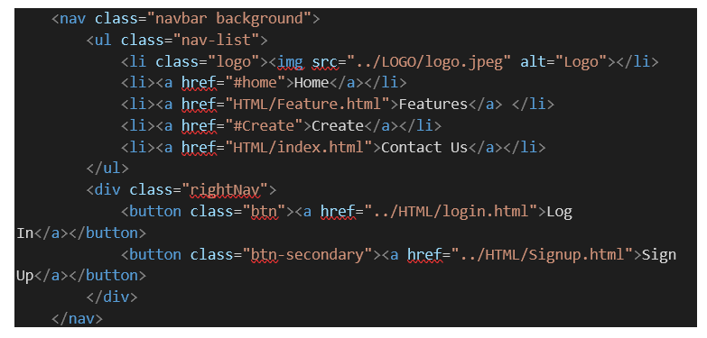

1. **Home page**

Section tag is used to make different sections to separate out the content. <section></section>. In this code we have also used <img></img> tag for inserting images and the buttons for directing you to create the ID card and certificate

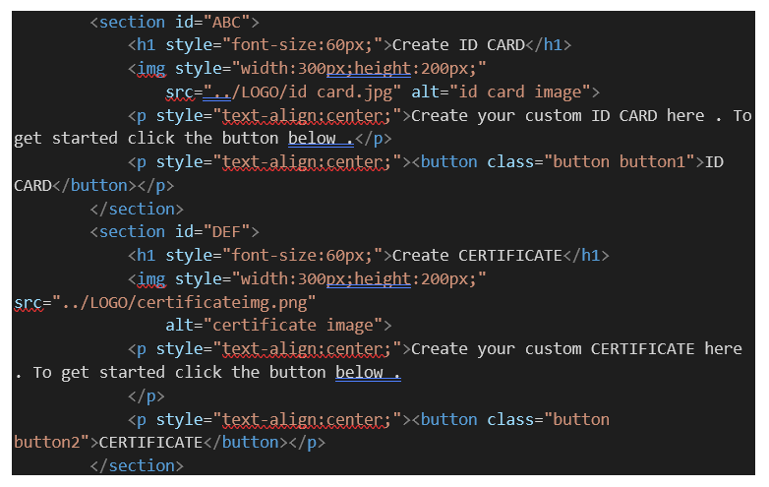

1. **Feedback module**

The feedback form consists of two parts one side contains all the icons which is given below. Tag <i></i> is used to insert the icons in the website.

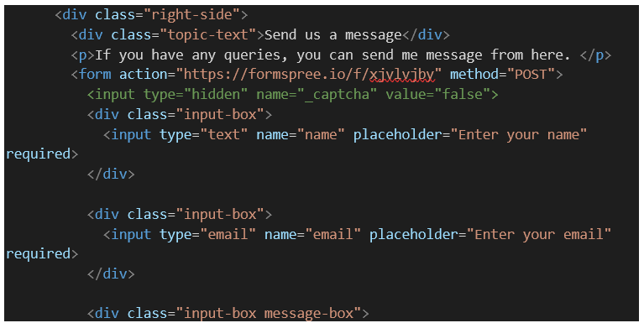

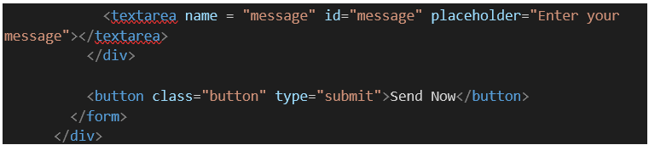

This is the second part of the feedback form. It consists of all the input boxes and also a submit button to send the information the user filled.

Form tag <form></form> it is used to make forms taking input from users and leading to it there is a “action” with the help of action we can get the email after the user submitted the form the method should be POST.



**CSS ( Cascading Style Sheets )**

1. **Initializing**

This is used to initialize the whole styling in the website

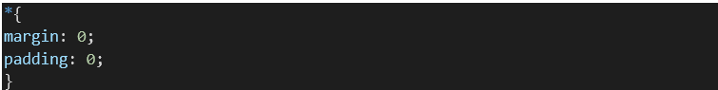

1. **Hover Effect**

This css is used for the hover effect i.e. when the mouse is taken over the keywords of the elements of this list with tag <a>.

border-radius - is use to apply curve to the box it depends how many pixels (px) you want.

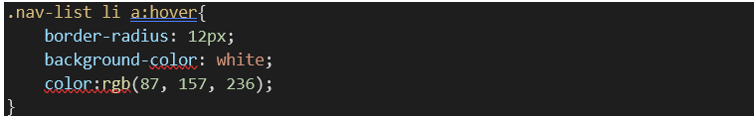

Few more :

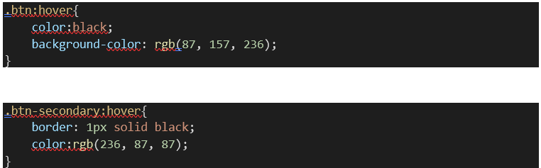

1. **Input From User**

This ccs code is used to style the user input in a form which we have used in the project. This change the color of the background of the input. [display] is used to make elements change the display in this case we have used inline-block.

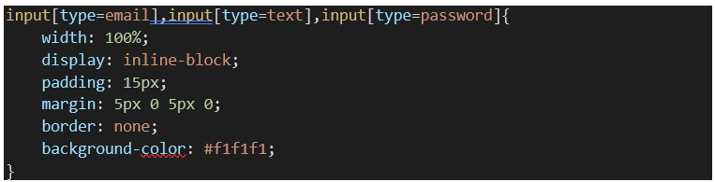

1. **Importing Fonts**

This code in css is used to import fonts in the project. There are many different fonts available throughout the internet we can use the particular link given with every font



**7. Result**

**Home screen**

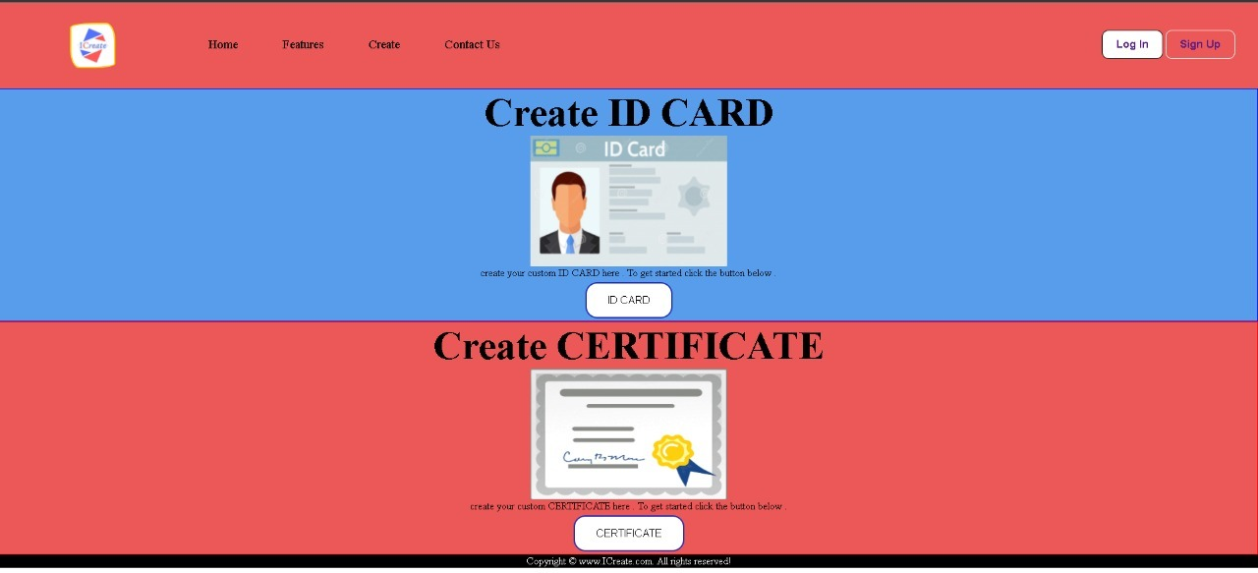

**Login /sign up**

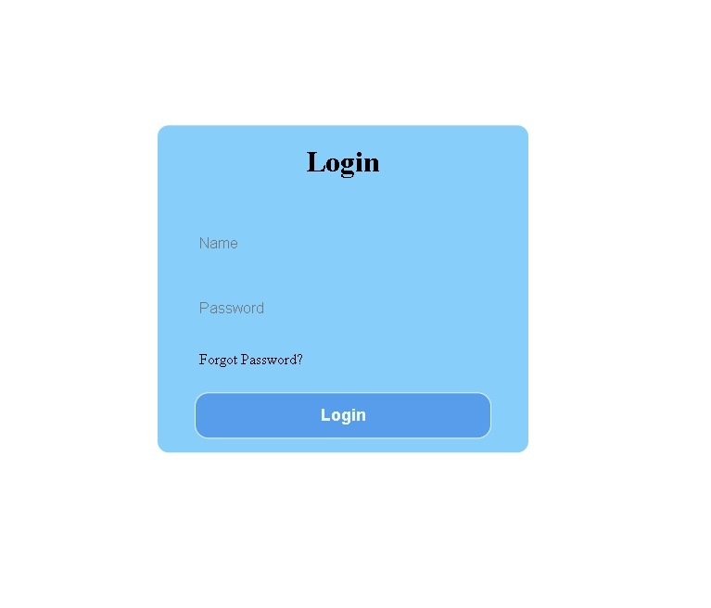

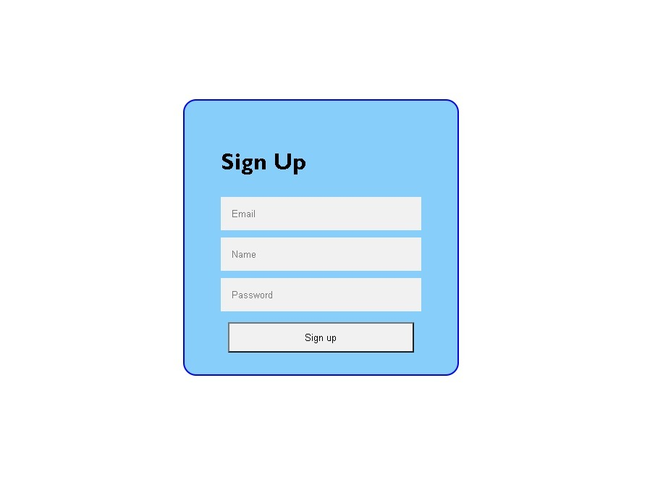

**Feedback form**

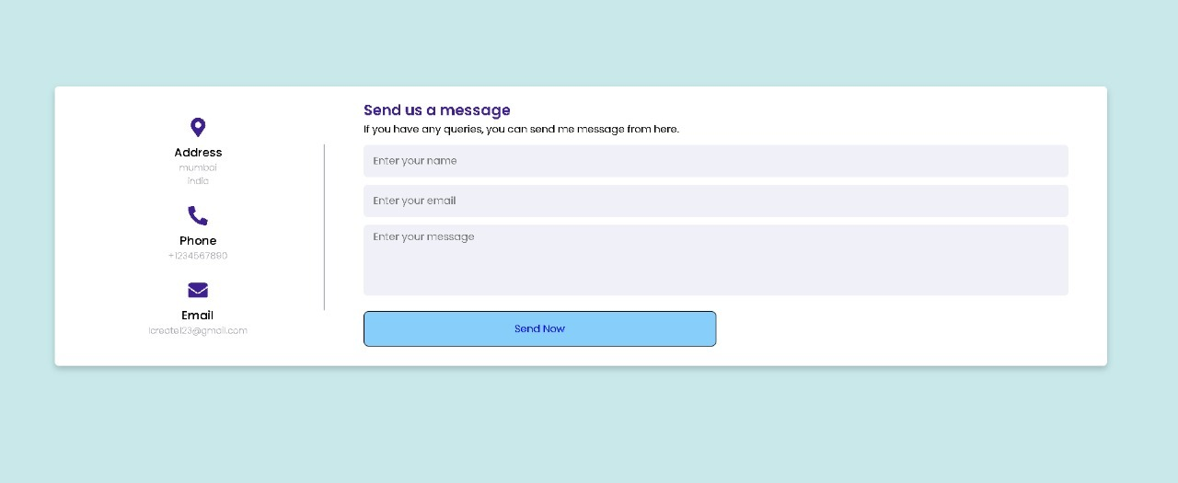

# **8. Bibliography**

1. <https://codeguid.com/2019/08/27/id-card-generator-project-in-java/>
2. <https://www.thesslstore.com/knowledgebase/code-signing-cert-csr-generate/java-keystore/>
3. <https://youtu.be/esMz10PiI4E>
4. <https://developer.mozilla.org/en-US/docs/Web/CSS/display>
5. <https://youtu.be/gggB0Nq5vBk>
6. <https://www.w3schools.com/html/>
7. <https://www.w3schools.com/css/default.asp>

**9. Appendices**

**Appendix-A: VS Code Download and Installation**

1) **Download the executable file from**<https://code.visualstudio.com/download>

2) **Click the option “download”.**

**3) Double click the downloaded file. Now a dialogue box appears. Select “ I accept the agreement ”** . **Then select “ Next ”.**

**4) Select a folder by clicking Browse or just follow the default path. Then select “ Next”.**

**5) Select the required options as per your need by clicking in the checkbox. Then select “Next”.**

**6) Select “ Install ”.**

**7) Wait a bit while it gets installed**

**8) Click “Finish” to exit Setup. Check in the check box to launch VS Code right now.**

**9) Congratulation! VS Code got installed in your system successfully. Now a new dialogue box appears. This is VS Code IDE.**

**10) Click New file to open a new file**

**Acknowledgement**

We have great pleasure in presenting the mini project report on **ICreate.** We take this opportunity to express our sincere thanks towards our guide **Prof.Ramya R.B** Department of Computer Engineering, APSIT thane for providing the technical guidelines and suggestions regarding line of work. We would like to express our gratitude towards his constant encouragement, support and guidance through the development of project.

We thank **Prof.Sachin Malave** Head of Department, Computer Engineering, APSIT for his encouragement during progress meeting and providing guidelines to write this report.

We also thank the entire staff of APSIT for their invaluable help rendered during the course of this work. We wish to express our deep gratitude towards all our colleagues of APSIT for their encouragement.

**Student name 1 : Smit panchal**

**Student ID 1 : 20102027**

**Student name 2 : Amit nara**

**Student ID 2 : 20102067**

**Student name 3 : Bhavesh pawar**

**Student ID 3 : 20102069**

**Student name 4 : Ujjwal pal**

**Student ID 4 : 20102054**